Ironmongery Specification

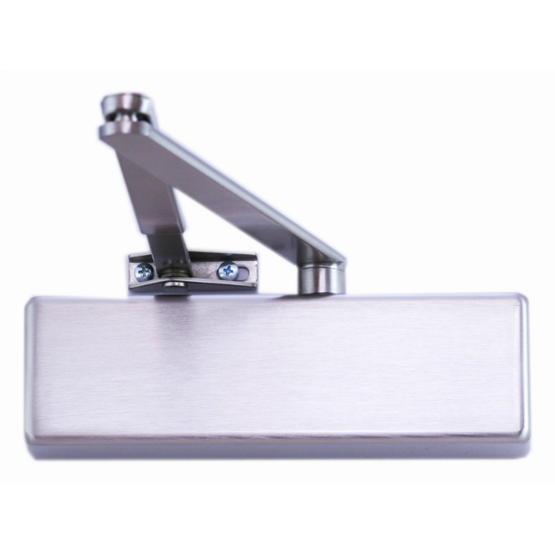

Product : ZDC0024
Description : Universal Door Closer Adjustable Power Size 2-4
Finish : Satin Stainless Steel Body & Arm
Testing : BS EN1154, CE Marked & Certifire Approved in Size 3

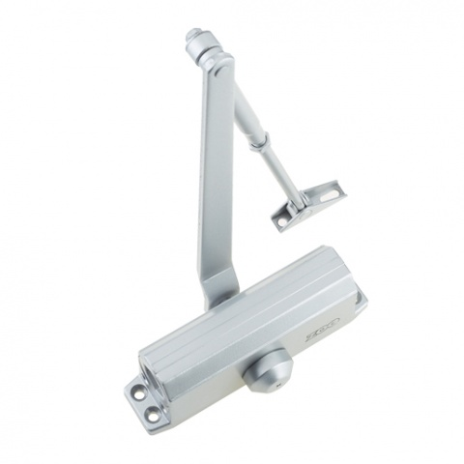

Product : ZDC003
Description : Fixed Power Size 3 Door Closer
Finish : Silver Enamel Body & Arm
Testing : BS EN1154, CE Marked & Certifire Approved in Size 3

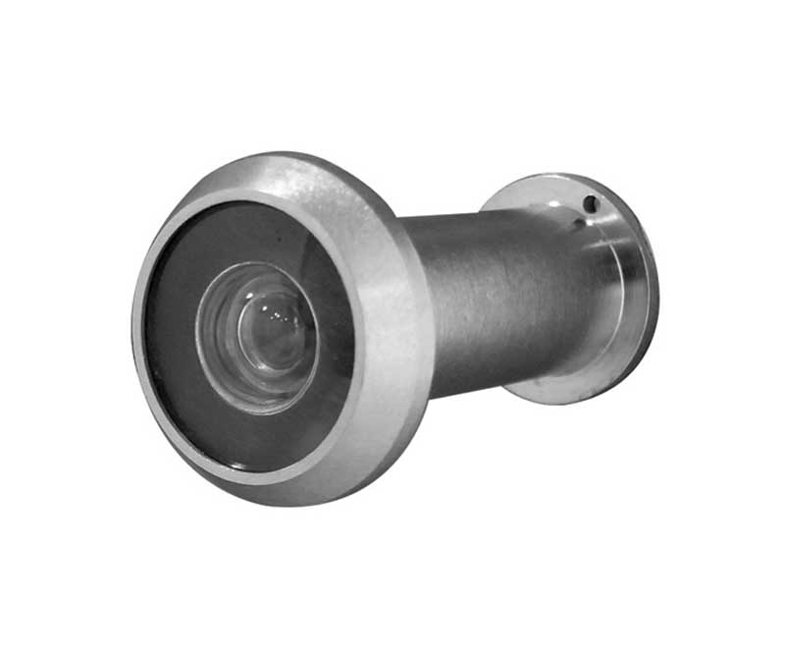
Product : 794SHU
Description : 180 Degree door Viewer
Finish : Satin Chrome Plated

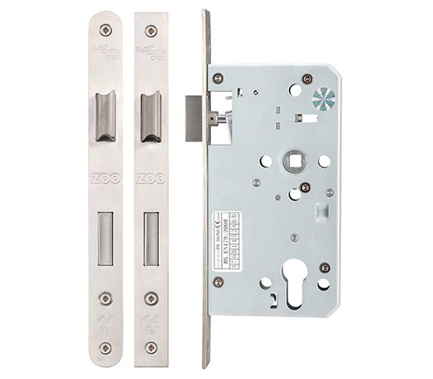

Product : ZDL7260R
Description : Euro-Profile Din Standard Mortice Sash Lock 60mm Backset, 72mm Centres
Finish : Satin Stainless Steel Faceplate & Strike
Testing : BS EN12209 : 2003 Grade 3, CE Marked & Certifire Approved

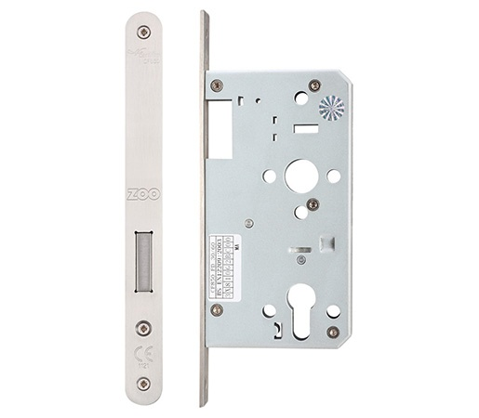

Product : ZDL0060R
Description : Euro-Profile Din Standard Mortice Deadlock , 60mm Backset
Finish : Satin Stainless Steel Faceplate & Strike
Testing : BS EN12209 Grade 3, CE Marked & Certifire Approved

Product : V10EP70CT
Description : Euro-Profile Cylinder & Turn Under master key & Construction Keyed
Finish : Satin Chrome Plated
Testing : BS-EN1303 Security Grade 2 Restricted 10 pin cylinder

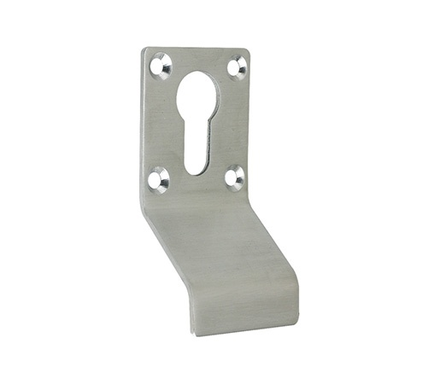

Product : ZAS16SS
Description : Euro Profile Cylinder Pull
Finish : Grade 304 Satin Stainless Steel

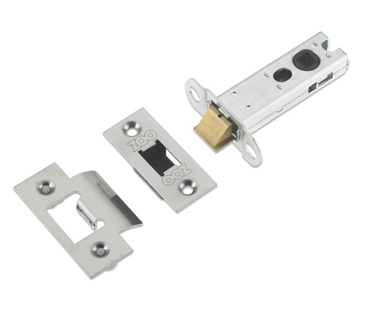

Product : ZTLA76R
Description : 76mm Heavy Duty Tubular Latch Radius Forend
Finish : Grade 304 Satin Stainless Steel

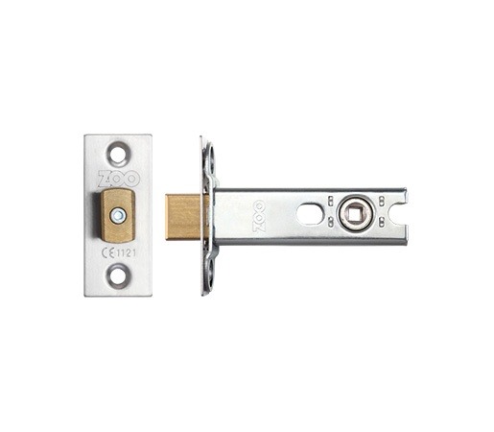
Product : ZTDA76R
Description : 76mm Heavy Duty Tubular Deadbolt Radius Forend
Finish : Grade 304 Satin Stainless Steel

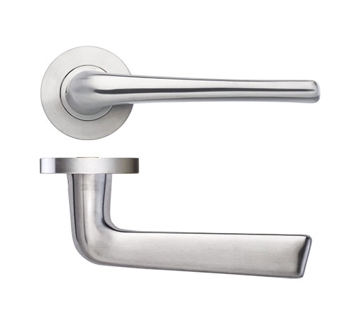

Product : ZCS160SS
Description : 19mm Lever on 52x8mm Sprung Rose
Finish : Grade 304 Satin Stainless Steel
Testing : BS EN1906 Grade 3

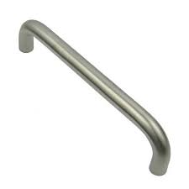

Product : OV6B/319SSS
Description : 300x19mm Pull Handle Bolt Through Fixing
Finish : Grade 304 Satin Stainless Steel
Testing : BS EN1634-1

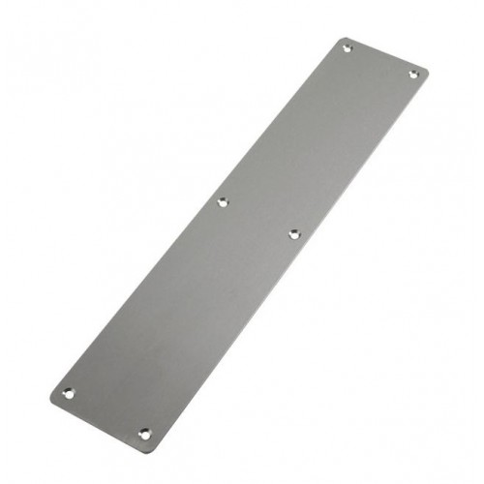

Product : TTFP338SS
Description : 330x75x1.5mm Finger Plate c/w Radius Corners
Finish : Grade 304 Satin Stainless Steel

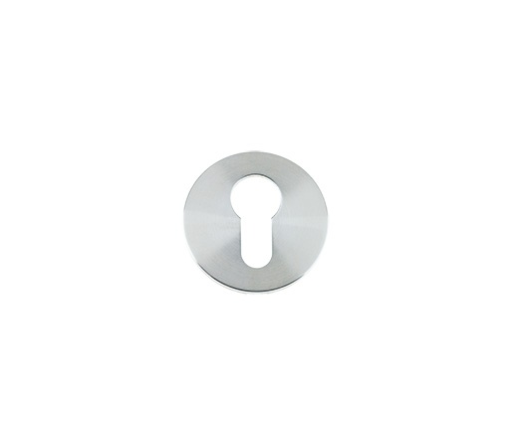
Product : ZCS001
Description : Euro-Profile Cylinder Escutcheon 52x8mm
Finish : Grade 304 Satin Stainless Steel

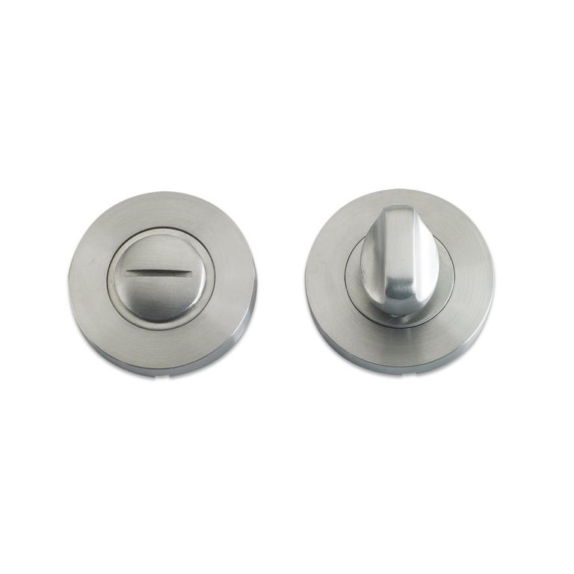
Product : ZCS004
Description : Bathroom Thumbturn & Emergency Release c/e Indicator 52x8mm
Finish : Grade 304 Satin Stainless Steel

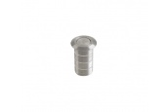

Product : SHP/1003/150/SC
Description : 150x25mm Necked Barrel Bolt
Finish : Satin Chrome Plate

Product : ZAS14SSS
Description : Dust Excluding Socket
Finish : Satin Stainless Steel

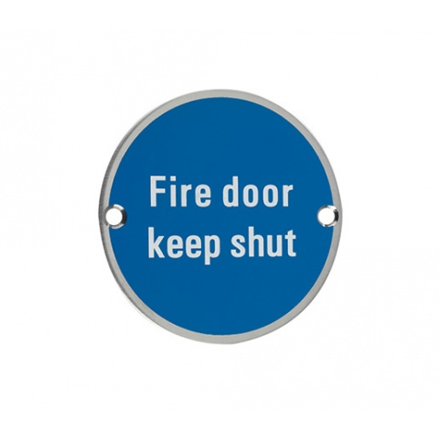
Product : TT606SS
Description : 75mm Dia Sign to Read “Fire Door Keep Shut”
Finish : Satin Stainless Steel
Testing : BS 5499-4

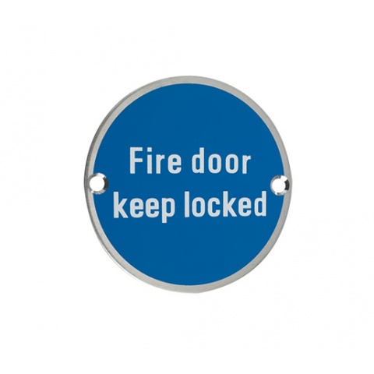
Product : TT605SS
Description : 75mm Dia Sign to Read “Fire Door Keep Locked”
Finish : Satin Stainless Steel
Testing : BS 5499-4

Product : AJC900X150SSS
Description : Kicking Plate 150mm High
Finish : Grade 304 Satin Stainless Steel
Notes : Size Specified is Nominal, Exact Site Sizes Required

